Creating a Moodle Quiz with Settings

- Navigate to the course, click “Create learning activity” in the proper section. Choose “Quiz” from the menu and click the blue ADD button.
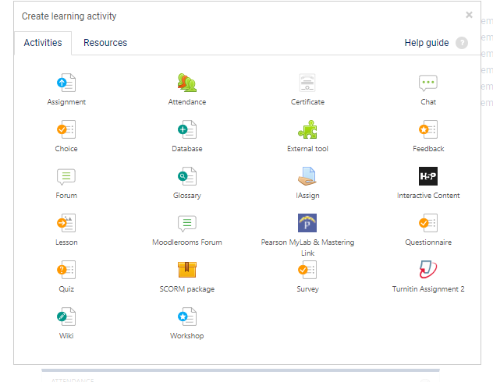

- This will open the settings window for your quiz:
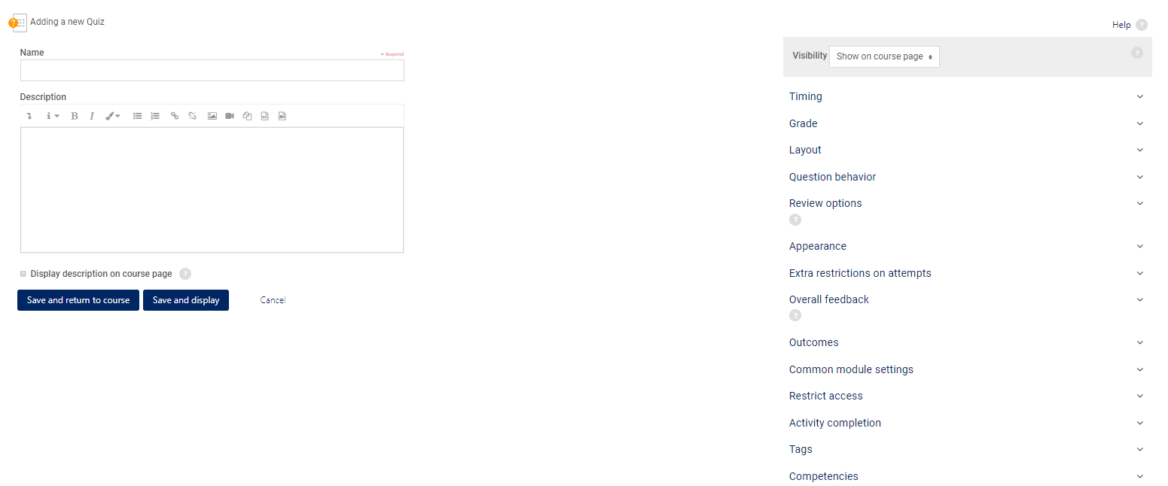

Enter the name for your quiz or exam. Description is optional but is a good place to put extra information regarding what the quiz will cover, special instructions, etc. You must click the “Display description on course page” if you want the students to see this information.
- The Timing section is one of the most important blocks of setting for a quiz. This is where you will set the open and close dates (limits when the student can take the quiz), time limits, what happens when time expires and if a grace period will be allowed.

Recommendations:
  - Opening the quiz is up to you. Do you want them to be able to access it at any time or only during a certain timeframe. You must check “Enable” to add dates and times.
Times use a 24-hour clock
  - Closing the quiz should be done if there is a definite due date/time for the quiz.
  - Time limit is instructor discretion. For online courses it is recommended to time the quiz so that every answer cannot be looked up or googled, unless this is okay with you. 30 seconds to no more than 1 minute per question is recommended (depending on question type).
  - When time expires should be left at “Open attempts are submitted automatically” unless you intend to offer a grace period. Do not set it at it at “Attempts must be submitted before time expires, or they are not counted! This setting will cause students to lose their answers if they do not submit by the time the timer runs out.
- The Grade section you will use only if you intend to allow the student more than one attempt on the quiz. (We recommend that you do not use grade categories.) If you allow the students more than one attempt then you will need to decide what grade will be recorded: Highest, Average, First Attempt or Last Attempt.
- Layout allows you to determine whether you want a new page for each question (we recommend you leave this as the default)
Navigation method can be “free” (meaning they can move around in the quiz, clicking on the questions in any order) or “sequential” (meaning that they have to answer the questions in order and cannot go back and revisit questions.
- Review Options is one of the most important setting block for a quiz (and the most frequent area for mistakes). Recommended settings are in the screenshot below:

  - Review Options:
During the attempt | = while taking the quiz
Immediately after the attempt | = the first 2 minutes after submitting
Later, while the quiz is still open | = after the first 2 minutes but before the quiz closes
After the quiz is closed | = after the set close date
The attempt | = being able to see the question and answer choices and how the question was answered
Whether correct | = green check mark shown if correct; red X if incorrect is shown
Marks | = score (must be checked for score to show in the gradebook)
Specific feedback | = individual question comments entered into the question bank, based on a correct or incorrect answer
General feedback | = general comments or information for each individual question, entered into the question bank
Right answer | = when question is answered incorrectly, the correct answer will be shown
Overall feedback | = comments regarding the quiz overall – does not pertain to individual questions

- Extra restrictions:

  - Require password – good for proctored exams
  - Require network address – not used at Carl Sandburg College
  - Enforced delays – only pertain if you have allowed multiple attempts. If so, you can force a delay before additional attempts to encourage extra study time.
  - Browser security –should stay at the default of “Full screen pop-up with some JavaScript security”. This will block the use of copy/paste and print.
- Overall feedback – allows you to display a comment(s) after quiz submission. Adding grade boundaries will allow different comments for different grade ranges. Ranges should always be highest to lowest with the comment in-between.

- Activity completion (if turned on in settings) will give a checkbox for students to work through their course like a to-do list… checking things off as they go. You can control whether an item is checked with rules such as “Require view” or “Require grade”. Please contact the FTLC if you need help with these settings.
SAVE AND RETURN TO COURSE. Note that your quiz is not yet finished as it does not contain questions.

