Select course dashboard
Select gradebook
Choose the option “Setup”

Change to Natural grading by selecting the edit button next to the name of the course. Shows up on the right hand side of the screen under “actions.”
Use pull down menu and change to Natural save changes

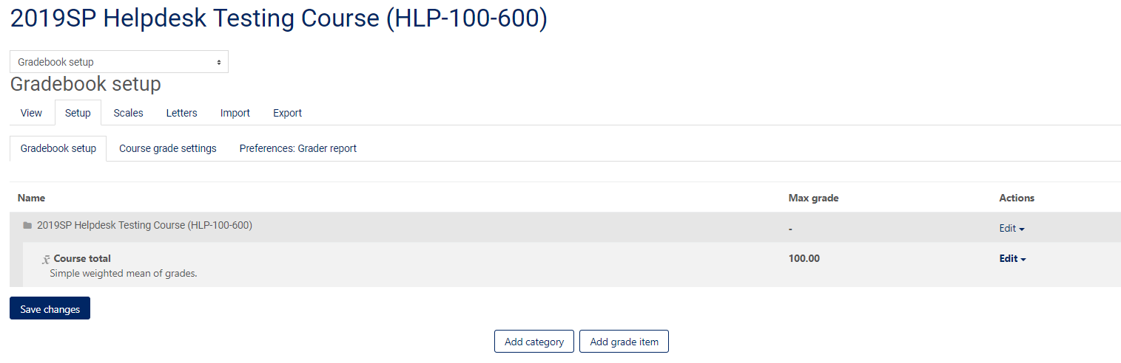
Select “ADD GRADE ITEM”

Provide name for the item, number of point to make it worth, select save changes.

To record the scores
Go back to Grader Report
Select the pencil on the item/assignment you want to add points. Once you do that you will have the opportunity to enter grades for the student(s).

