Blackboard Open How To’s
Faculty Teaching & Learning Center (FTLC) is available to help with specific questions at ftlc@sandburg.edu or by
calling 309-341-5438. Normal hours are 8 a.m.-5 p.m. (summers 4 p.m.) Special hours are available upon request. FTLC is located in room E233a (close to the library).

Move sections
Navigate to the section to move, select the right arrow icon below that section
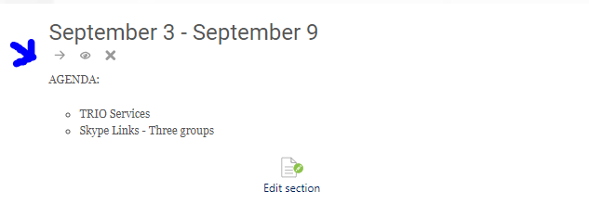
Select the new desired position
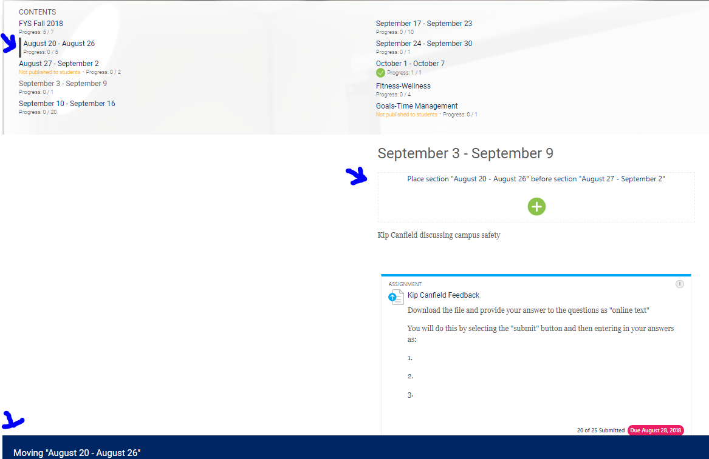

Move learning activity
Navigate to the learning activity to move, select the right arrow icon below that item
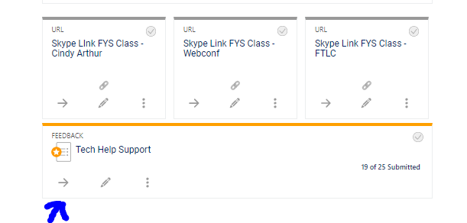
Select the new desired position
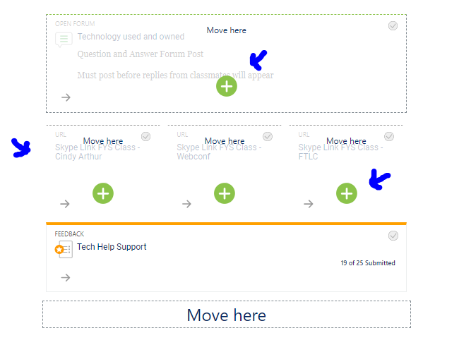

Add quick mail feature
Select “Course Dashboard”
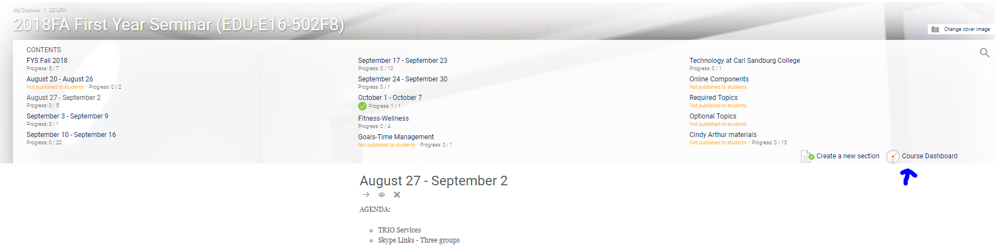
Select “Edit blocks,” scroll down to option to “Add a block” 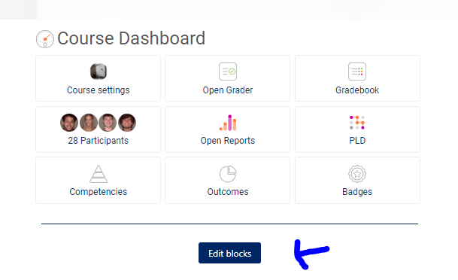
locate “quickmail feature, ”

move quickmail to a different location if desired by selecting “+” icon and “Turn editing off”
option is now available to compose “New Email” to one or all students in your course
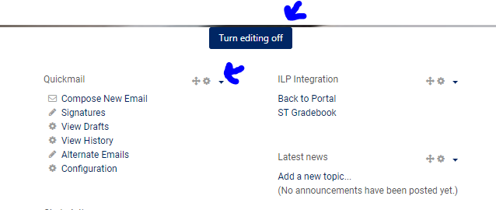

Import Course previous semester
Navigate to the empty course and select “import” from the cog wheel in the upper right hand corner
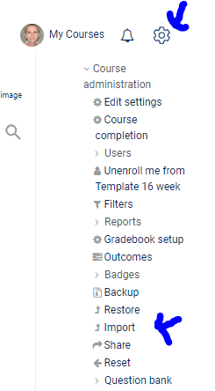

Enter the name of the course from the previous semester, select “continue”
Options will be made available to select ALL or to customize the import
Once the import is completed, the course will appear.
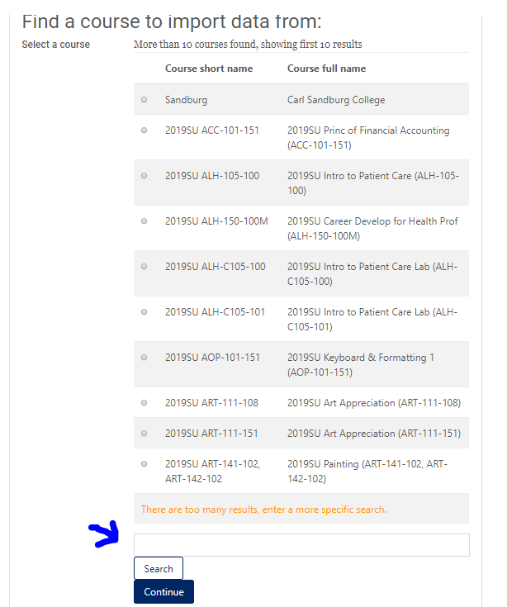

Topics vs. Weeks
Sections are arranged by “Topics” or “Weeks”
To change/customize the section labeling, navigate to the section and select “Edit section”
Tick the “Custom” box and add the desired label and “Save changes”
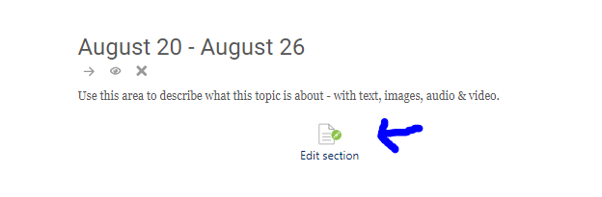
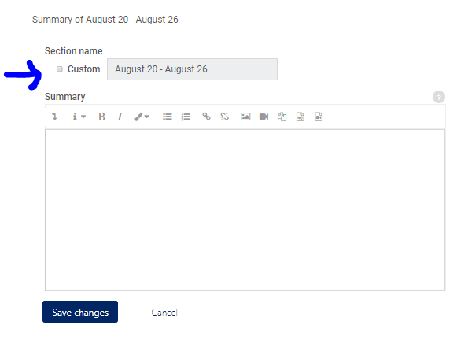

Hide section or activity
Select the “eyeball” icon to hide or show a section or activity
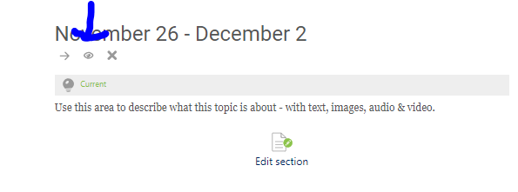

Create learning activity or add resources
Blackboard Open provides a wide range of learning activities for students to complete. Popular choices include forums, quizzes, and assignments. The options are available by navigating to the section and then selecting “Create learning activity.” Once a “Learning activity” is selected many options will be made available (points, due dates, etc.) By selecting the “help guide” button in the top right corner a detailed explanation of each activity will be provided. Please contact the FTLC with specific questions.
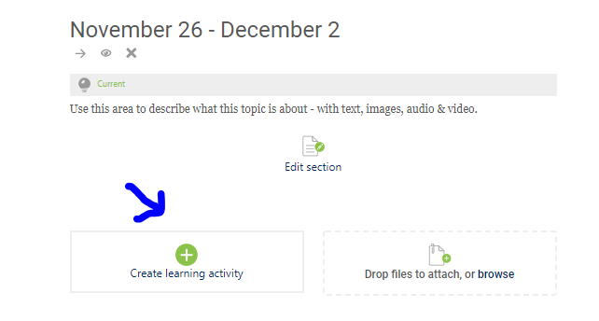
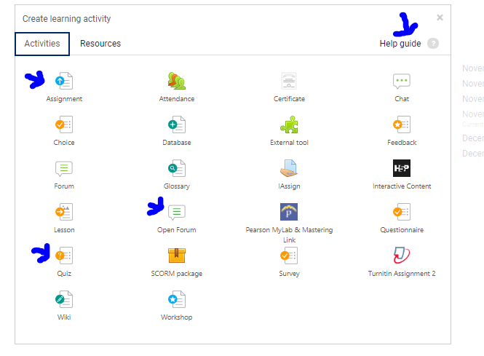

Create test/quiz
Please contact the FTLC for more detailed information on this topic. Many times test banks are available from the publisher. Once test banks are made available from the publisher, the FTLC can determine the best method for importing into the course.
Once the test bank questions are imported, quiz/test can be added.

Gradebook
Please contact the FTLC for more detailed information on this topic. The gradebook provides many options ranging from adding manual items to weightings to dropping lowest scores. Activities created within Blackboard Open with points assigned will automatically be added to the gradebook.

Information on Concourse Syllabus Template, Accessibility, and several other helpful resources/information are available on the FTLC webpage
http://www.sandburg.edu/About/FTLC/index.html

