Adding Attendance Module to a Course

- In the first section (Introduction) of your Moodle course select “Create learning activity.”
  - Choose Attendance
  - Options will appear to name the module and on the right an option will appear for assigning a grade to Attendance
    - Change the name if you wish.
    - Change the grading option if you wish (it defaults to 100 pts).
    - Select save and display

  - Select the Add session tab
    - Check – Repeat the session above as follows
    - Repeat on- (tick the boxes for the days the course meets per week)
    - Repeat every-leave this at 1 week!
    - Repeat until-add the end of the semester/term date
    - Save

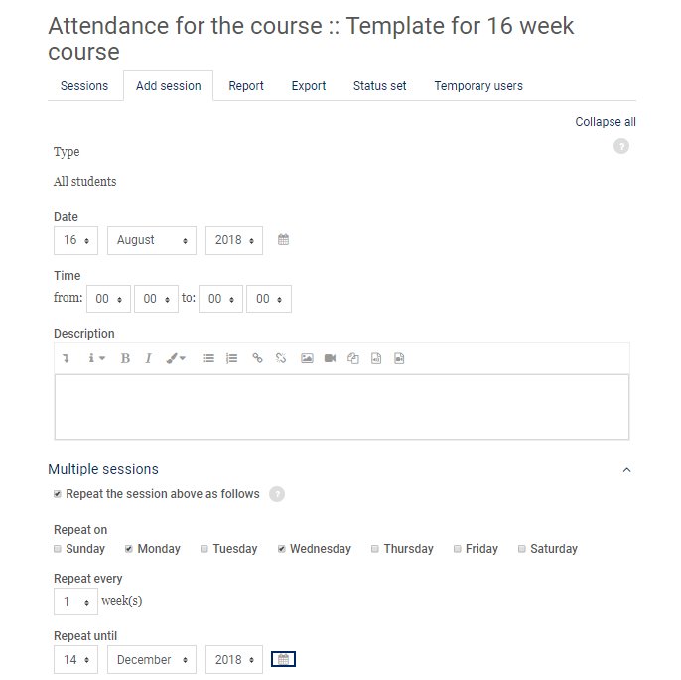

- To take Attendance, click Attendance and select the arrow icon on the appropriate day.
